Gender Bender
How the media influences our perceptions of gender

Author: Jenny Lovell, PhD Student ENVS Dept, UC Santa Cruz; Santa Cruz, CA

Field tested: 10th Grade ECHO CORE, Watsonville High School, Watsonville, CA (Fall 2014) 11th Grade Psychology Class, Watsonville High School, Watsonville, CA (Spring 2015)

Module Type: Classroom Activity

Duration: 10 minute preparation lecture, and up to 2-hr class session

Key materials:
- Computer or device with a web browser (IE®, Google Chrome®, Firefox®, etc.), and Microsoft Word® installed – one for each group
- Projector with sound and video capabilities

Concepts: Analyzing media images, Stereotypes, Gender identity, Gender expression, Biological sex, and Sexual orientation

Skills: Gathering appropriate web-based data, Synthesizing and Presenting an inquiry-based project

NGSS Practices: 7. Engaging in argument from evidence, 8. Obtaining, evaluating, and communicating information
NGSS CCC: 1. Patterns: prompt questions about relationships and causes underlying them

Overview:

This module is an opportunity for students to gain a better understanding of the complexity of gender and how stereotypes are perpetuated through popular media. Students brainstorm and discuss stereotypes, talk about gender conditioning they have witnessed, and begin to uncover the constant reinforcement of the gender binary that the media supports. By the end of the lesson students will learn:

- The definitions and nuances of gender
- Strategies for analyzing images to uncover stereotypes
- How to verbally describe non-verbal queues contained in an image

Navigate: Background Materials &Time Starting Point Procedures Standards Supplemental

Background for Teachers

Why this matters: Gender is a relevant and contentious topic that is constantly reinforced through non-verbal queues in the media. LGBTQA (lesbian, gay, bisexual, transgender, queer, and questioning) issues are hotly debated in schools, courts, and public media venues. While most people think of gender as a simple binary (i.e. man or woman), gender is a complex and delicate continuum that includes many aspects that are not often discussed.
Assumed background: Students must be comfortable conducting an oral presentation in front of classmates. No other prior knowledge is necessary.
Scaffolding supplements:
- Gender Lecture (Attached)
- Gender Activity Worksheet (Attached)
- TED Talk by Sam Killermann (https://www.youtube.com/watch?v=NRcPXtqdKjE#t=21)

Module Description

Materials:
- Computer or device with a web browser (IE®, Google Chrome®, Firefox®, etc.), and Microsoft Word® installed – one for each group
- Projector with sound and video capabilities

Preparation:
- Print or upload worksheets for the students to complete in class (Gender Activity)
- Break class into groups of 2-3 maximum
- Preview the Video (TED talk by Sam Killerman)

Timeline:
- Introduction and “Do Now” box on Worksheet (5 minutes)
- Gender Box exercise (15 minutes)
- TED Talk Video: Sam Killermann (15 minutes)
- Presentation and class media analysis (25 minutes)
  - Present PowerPoint and example images
  - Class breaks the examples down together
- Groups break out and find their own images (30 minutes)
- Group presentations (30 minutes)

Starting Point For Inquiry:

There are many stereotypes associated with being a “man” or a “woman.” This exercise is designed to discuss those assumptions and analyze how they are reinforced in the media every day. When we think of gender, we think of these two words: man and woman. However, gender is much more complex than a simple binary.

The best way to break gender down into more complex and accurate parts is through three key vocabulary words: gender identity (how you think about your own gender), gender expression (the way you express your gender identity though actions, dress, words, or behavior), and biological sex (male and female sexual organs).

Now think about how stereotypes about “men” and “women” are reinforced, perpetuated, and policed. From the minute a baby is born, they are dressed in masculine or feminine colors, given gender-appropriate toys, and taught how to behave in a gender-specific manner. For example, the phrase “boys will be boys” indicates that biological sex determines how young men behave, rather than social conditioning. Girls wear pink, while boys wear blue. Understanding the visual and verbal ways that these stereotypes are continued can help students question their validity and break down false assumptions.

Detailed Procedure:
- Introduction and “Do Now” box on Worksheet (5 minutes total)
  - Introduce the topic of gender and give the students a general outline of the day (1 min)
  - Do Now: Think of a book, film, TV character that represents a “man” to you. Who is it and why? Think of a book, film, TV character that represents a “woman” to you. Who is it and why? (4 min)
- Gender Box exercise (15 minutes total)
  - Draw two giant boxes on the board and introduce the key concept of a stereotype
  - Ask the students to brainstorm stereotypes about what is “Manly” (7 min)
  - Ask the students to brainstorm stereotypes about what is “Ladylike” (7 min)
- TED Talk Video: Sam Killermann (15 minutes)
  - Killerman covers 4 main vocabulary points. Try to stop the video when he reaches the conclusion of each explanation to reword the ideas for the students because he talks very quickly.
- Presentation and class media analysis (25 minutes)
  - Example images: Jane the Virgin, Arrow, and the cover of a Beyonce/Jayze album
  - Class breaks the examples down together
- Groups break out and find their own images (30 minutes total)
  - Go over the group project questions individually, allowing for students to ask clarifying questions (5 min)
  - Break into groups (5 min)
  - Find an image and have the instructor approve appropriateness (5 min)
  - Group discussion of each of the worksheet questions (15 min) *Be sure that each group member is ready to speak/discuss one or more questions
- Group presentations (30 minutes)

Assessment Methods:
The culminating assessment is an oral and visual presentation. The students display the image they choose to analyze, discussing the elements of the image that reinforce or depart from gender stereotypes.

Possible pitfalls:
This is a sensitive subject for students. Students may identify outside the stereotypical gender roles, or they may hold strong opinions about those who may not fit in. It is important before beginning any of the exercises to emphasize respect for difference, non-violence, and creating a “safe zone” within the classroom. In other words, students need to be able to discuss gender stereotypes openly. A good solution to this issue is to start the class by verbalizing the assumption that all students are discussing stereotypes they have noted, observed, or experienced; rather than stereotypes they agree with or believe. This gives a sense of anonymity to each student’s contribution and allows an open discussion.

Glossary:
Gender Identity: the internal perception of an one’s gender, and how they label themselves, based on how much they align or don’t align with what they understand their options for gender to be. Common identity terms include man, woman, genderqueer...

Gender Expression: the external display of one’s gender, through a combination of dress, demeanor, social behavior, and other factors, generally measured on scales of masculinity and femininity.

Biological Sex: a medical term used to refer to the chromosomal, hormonal and anatomical characteristics that are used to classify an individual as female or male or intersex. Often abbreviated to simply “sex”.

Sexual Orientation: the type of sexual, romantic, physical, and/or spiritual attraction one feels for others, often labeled based on the gender relationship between the person and the people they are attracted to (often mistakenly referred to as sexual preference)

Media: film, television, music, newspapers, magazines, online sales

NGSS Standards Addressed

Science & Engineering Practices
7. Engaging in argument from evidence
8. Obtaining, evaluating, and communicating information

Cross Cutting Concepts
1. Patterns: prompt questions about relationships and causes underlying them

Guide to supplemental materials

Gender Activity (GenderActivity.docx)
A worksheet activity completed in class to supplement the lesson

Gender Presentation Images (GenderPresentationImages.pptx)
A PowerPoint presentation of images from popular media that instructurs can use to
demonstrate to students how popular images can be reinforce gender sterotypes in society.

Graphics
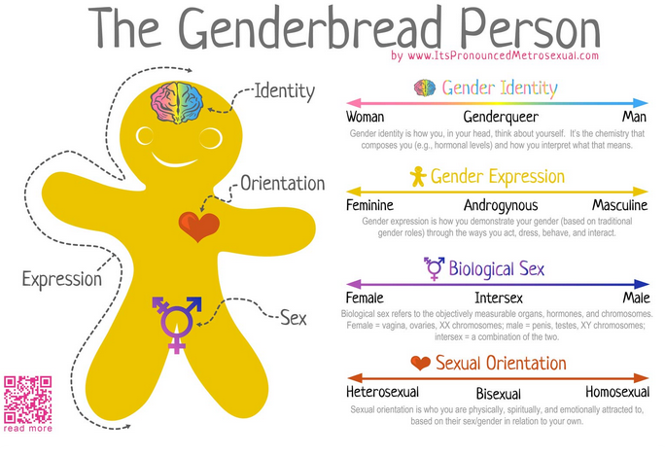

Worksheets
Gender in the Media Activity Worksheet

Videos
Sam Killerman Ted Talk

Assessment Materials
N/A

