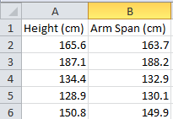
Making an X-Y scatter plot in Excel 2007 or 2010
Figure 1 - Your data should be entered in columns like this. DO NOT use the data above – it should be replaced with the values you measured!
- Organize your data into two columns. In cell A1, write “Height (cm)”. In cell A2, write “Arm Span (cm)”. This will help you keep track of your data. Place your X-values (Height) in column A, and Y-values (Arm span) in column B. Remember that all of these values should be in centimeters! When you are done with this step, it should look like Figure 1.
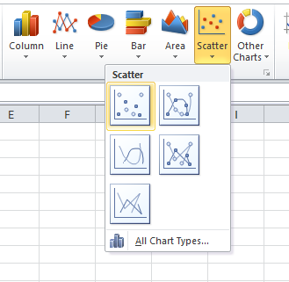
- When you are done, highlight all your data (including the labels you made in row 1). Go to “Insert” and click on the box marked “Scatter”. A dropdown menu will appear and will let you select from a few options (Figure 2). We only want our data – no lines or curves yet – so select the first option that appears. It is named “Scatter with only Markers”
Figure 2 - Select the first option under Scatter

- Excel will automatically make a scatter plot for you, but there are a few things wrong with it. Let’s correct this. First, you’ll notice that Excel titled your chart “Arm Span (cm)”, which is NOT what we want to title our chart. Double click on this title to rename it. Think carefully about what the best name for this chart is!
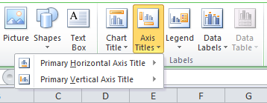
- We also need to add X- and Y-axis labels so that people looking at our charts know what we are investigating. Click once anywhere inside the chart. At the top of the screen, you will see the “Chart Tools” tabs appear, which include “Design”, “Layout”, and “Format”. Click on “Layout”. Look for a button titled “Axis Titles” (Figure 3). Using this, you can rename your axes. Don’t forget to include units in your axes’ names!
Figure 3 - Under "Axis Titles" you can rename your X- and Y- axes
- You’re now ready to add a trendline and R-squared value to it. Right-click on any of the data points on the chart, and in the menu that pops up, select “Add Trendline…”
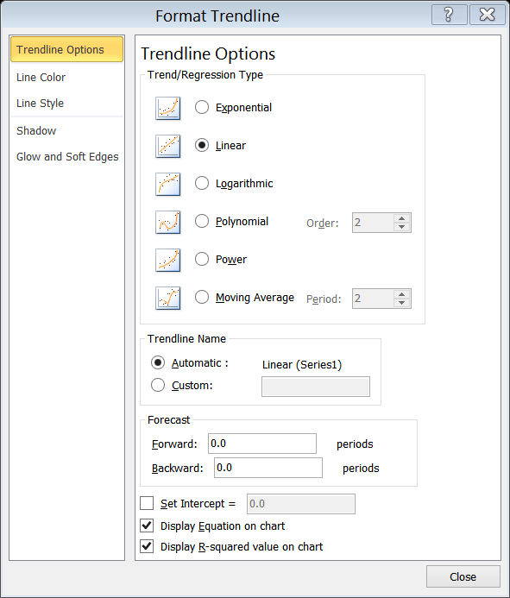
- A window will pop up that allows you to select the type of trendline. Today, we will use the “Linear” option, so select it. Towards the bottom of the window, you will see options to “Display Equation on chart” and to “Display R-squared value on chart”. Select both by checking the boxes next to them, and then click “OK”. Congrats, you have now successfully made a scatter plot with a trendline and R-squared value!
Figure 4 - Choose "Linear" from the Trend/Regression Type, and then click on the boxes next to “Display Equation on chart” and "Display R-squared value on chart"

