Bioacoustics Lab: What’s that Sound?
**Don’t forget your ear buds / head phones**

Objectives: The purpose of this lab is to understand the properties of sound in order to describe (quantitatively and qualitatively) the diversity of sounds produced by marine mammals. All analysis will be conducted using the program Raven Lite 1.0. For each file, you will create a waveform and spectrogram for analysis (see examples below). For each species, you will obtain a variety of measurements including the duration of a call, the power at peak frequency, the peak frequency, the frequency range, and any qualitative descriptions of the call.

To Begin: Double click on the Raven Lite icon. Open the file titled “CAsealion_male.wav.” You will have a waveform and a spectrogram for a California sea lion, which should look like the following:

The command panel in Raven– Use the illustration below for working with both waveform and spectrogram plots throughout the lab

To play the sound – click the icon.

Export/Copy image
(remember to save the images for your lab report!!!)

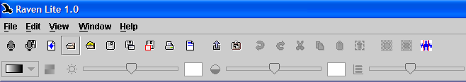

Zoom in to highlighted area or zoom out. Very useful for taking measurements.
Changes speed of playback (↑ to hear blue/fin whale sounds). 0.5= half speed, 1= real speed, 5= 5x fast, etc.)
Playing commands
Zoom in to highlighted area or zoom out. Very useful for taking measurements.
Hide Axes
Use to change the color scale of the spectrogram (color, grayscale, etc.) This is VERY useful when trying to visualize the calls.
Show / Hide Waveform
Show / Hide Spectrogram

Hints:
- Make sure both waveform and spectrogram are turned on
- Use zoom in and out to focus on specific calls
- Adjust color scale to help visualize call
- Adjust brightness to help determine peak power and peak frequency

How to fill out the worksheet from the lab (example):
Below is an example for the male California sea lion.

- Adjust color scale so that you can see the spectrogram clearly

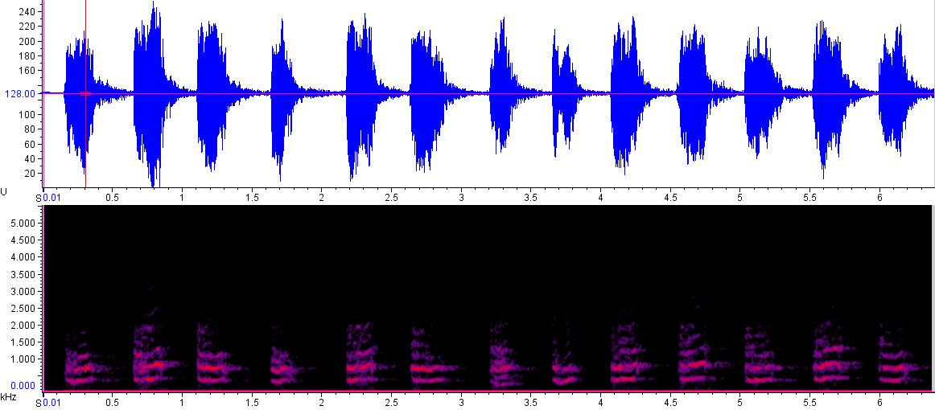
Pressure (db)
FFrequency (kHz)
Time (seconds)

- Examine one of the calls from the CA sea lion. I will look at the second call for this example

Pressure (db)
FFrequency (kHz)

Time (seconds)

- Now determine the start and end time of a call and call duration (time between the start and end of a call).

Highlight the call and place your cursor on either side of the call. You should see the time appear on the lower left when you are on either graph. In this case the start time is 0.648 sec and the end time is 1.102 sec. Therefore the change in time, or call duration is 1.102 - 0.648 = 0.454 seconds

Time (seconds)
Frequency (kHz)
Pressure (db)

1.102 s
0.648 s

- Determining Peak Power (in decibels, db): Peak power is where the intensity of color is the greatest (brightest). First, zoom in on the entire call by selecting the call (as seen above) and then pressing the zoom button. Now zoom in again on the area with the loudest sound (greatest amplitude pressure waves.

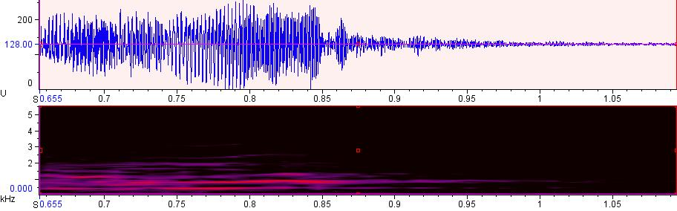
Time (seconds)
Pressure (db)
Frequency (kHz)

Now place your cursor somewhere in this loud region (I just picked roughly the highest amplitude (loudest noise)). Follow the line down to the spectrogram and look for peak power. If you move the cursor along the vertical line in the spectrogram, you will see the power value change on the lower left. If you place the mouse over the brightest color on that vertical line, you will see that this value is somewhere between 71 and 74 db.

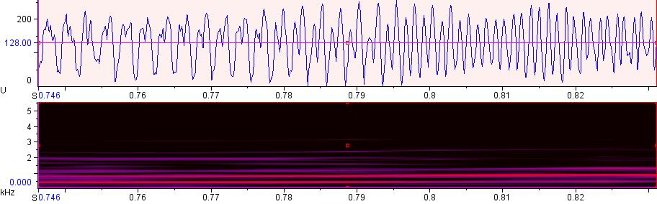
Pressure (db)
Frequency (kHz)

- Determining Peak Frequency:
This part is simple. Keep your cursor on the area of the spectrogram with the peak power and read the value for the frequency. Your value should be around 780 Hz.

- Determining High/Low and Change in Frequency:
Zoom back out so you can see the entire audio record or the entire call. Place your cursor over the graph at the highest and lowest place you still see color. You should see the following values (approximately) : High: 1916 Hz; Low: 260 Hz

Time (seconds)
Frequency (kHz)
Low Frequency
High Frequency

Species (file name) | Species Category | Time Start (s) | Time End (s) | Δ Time (sec) | Peak Freq. (Hz) | Power at Peak Freq. (dB) | High Freq (Hz) | Low Freq (Hz) | Δ Freq. (Range for all calls; Hz) | Comments:
Male CA sea lion | Sea lion
Northern Fur Seal | Sea lion
Beluga Whale | Toothed whale
Killer Whale | Toothed whale
Blue Whale | Baleen whale
Humpback Whale | Baleen whale
Weddell Seal | True seal
Harbor Seal | True seal
Mystery

My Mystery Sound File is: _________

Follow-up questions:

- What species do you think produced your mystery sound and why (justify your answer using the sound properties you measured)?

- Based on what you learned about marine mammal communication, do you think human-made noise can impact marine mammals? Why or why not?

