NAME: ________________________________
What’s that Sound?
Sound is especially important for marine mammals. In today’s activity, you’ll learn about bioacoustics, properties of sound waves, and the characteristics of marine mammal sound. You’ll learn enough to identify the species of your own marine mammal mystery sound!

- Acoustics is the study of _________________.

- Bioacoustics combines _____________ and ____________.

- Provide three reasons why marine mammals use sound underwater.

- Sound is a ________ that travels 5 times__________ in water than air.

- Label and define the following:
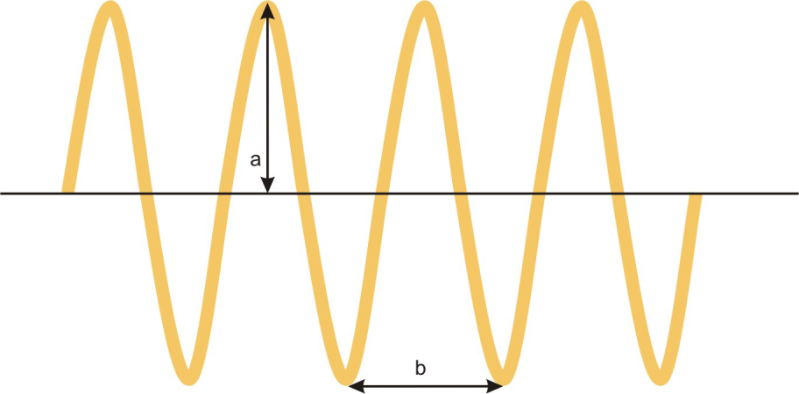

- Frequency is the number of _____________ per ______________.

- Which wavelength has the highest frequency? Lowest? The most energy? The last amount of energy?

Long wavelength = high / low frequency = high / low energy
Short wavelength = high / low frequency = high / low energy

- Low frequency sounds travel ___________than high frequency sounds underwater.

- A waveform (example below) shows __________ fluctuations over ________, with amplitude indicating _______________.

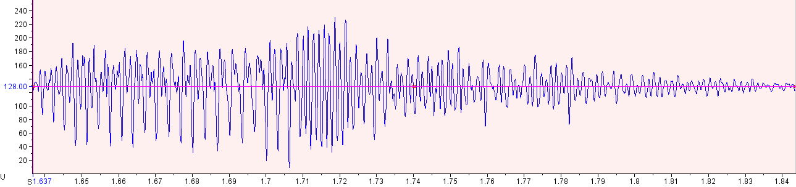
Pressure
Time (seconds)

- A spectrogram (example below) shows ______________ over_________, with color indicating ______________, or _______________.

Time (seconds)
Frequency (Hz)

- Peak Frequency: the frequency with the most ____________.

- Marine Mammal Bioacoustics Review Table
Marine Mammal Group | Example | Common Frequencies | Use
Mysticetes  (baleen whales) | blue whale
Odontocetes  (toothed whales) | Bottlenose dolphin
Pinnipeds  (seals & sea lions) | CA sea lion

