Name:________________

Period:_______________

Size Matters:
Understanding the Surface Area-to-Volume Ratio

Ever wonder why cells are so small? Living cells require food, water, and oxygen and must excrete waste. This happens though a process called diffusion, or the movement of molecules across a membrane from an area of high concentration to an area of lower concentration. In the same way, oxygen enters a cell and carbon dioxide exits the cell. Cells are dependent upon diffusion and the surface area must be large enough to expel waste material at a rate to sustain metabolism.

Surface area (SA) is the area of material that would be needed to cover an object (e.g. the amount of wrapping paper to wrap a really expensive gift for your science teacher).
Volume (V) is the amount of space inside an object (e.g. how much water in a mug.
Surface area-to-volume ratio (SA:V) is the proportion of area of a material covering an object to the amount of material inside the object.

Cubes by definition, have 6 sides, each of the same length (length = s).
SA = s² * 6 (# sides) for a cube.
V = s³ or l x w x h (length x width x height, all side length s) for a cube

Calculate the SA, V, and SA:V for each cube:
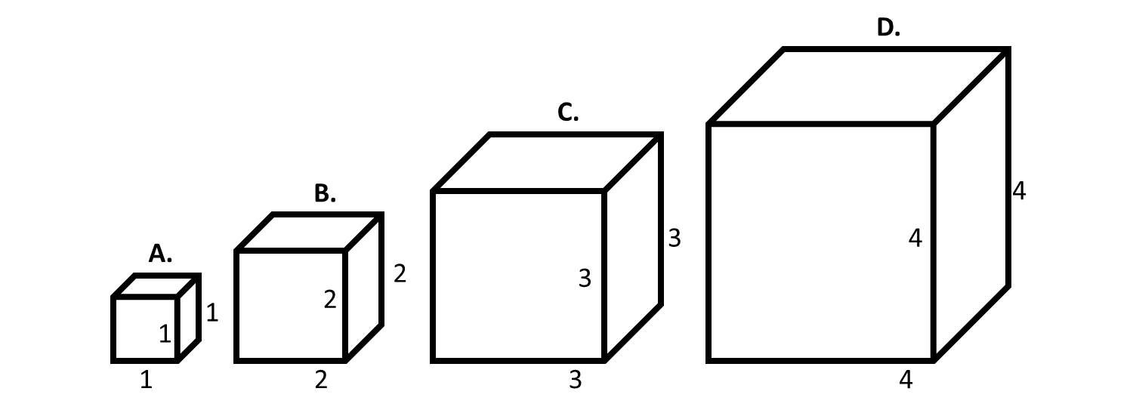

Cube A Cube B Cube C Cube D

SA _____________ SA ___________ SA ___________ SA ___________

V_______________ V______________ V____________ V_____________

SA:V __________ SA:V __________ SA:V _________ SA:V __________

What happens to the SA:V ratio as the cube gets larger?

Do cells in your body need a high or low surface area to volume ratio? Why?

If these cubes were cells in your body, which one would have the highest rates of diffusion? Why?

As a cell grows in size, what happens to the volume of its cytoplasm relative to the surface area of its plasma membrane? (hint: is the rate of increase faster of slower?)

What is one challenge that a cell might have if it has a large volume of a cytoplasm relative to its surface area?

