Experiencing the scientific process by investigating spinning tops

Authors: Max Tarjan, Kristin de Nesnera, Rob Hoffman

Field tested with: 6th grade, Pajaro Middle School (Fall 2014); Science fair class, Watsonville High School (Fall 2014); 4th-10th grade, Expand Your Horizons symposium (Fall 2014)

Module Type: Mini-investigation/ lab activity

Duration: 90 minutes

Key materials:
- printed handouts  - scissors  - drawing compasses  - pennies  - ¾” masking tape  - stopwatches  - 1” rubber bands  - pencils, small scoring | - pencils, standard  - 9” x 12” posterboard rectangles  - pencil sharpeners  - metal paper clips, No. 1  - 12” rulers  - 5” paper plates, heavy  - 9” or 10” paper plates, heavy  - homemade tops

Topics covered:
- asking a testable question
- experimental design
- collecting data
- interpreting data
- communicating conclusions using evidence
- making a poster to communicate results (optional)

NGSS Practices:
Practice 3 Planning and Carrying Out Investigations: (NGSS Appendix F Science & Engineering Practices, p. 7)

Some activity components (diagrams, materials list, and facilitation tips) are modified from the following document:

Exploratorium Institute for Inquiry (2006). Workshop I: Comparing approaches to hands-on science in Fundamentals of Inquiry Facilitator’s Guide. Exploratorium, San Francisco.

Exploratorium copyrights apply.

Introduction for Teachers

Why this matters:
Independently planning and conducting investigations can be a daunting process for students. This module will prepare students to carry out a study from beginning to end and to experience the feeling of ownership that can make the process easier and more exciting. This mini-investigation will prepare students for the scientific process by exposing them to a small-scale study where they will use many of the skills necessary to complete independent projects. This module will expose students to authentic scientific practices, such as making observations, asking questions, designing an experiment, recording data, analyzing their results, and reporting their findings. Students should come away from the module with a better understanding of the scientific process. For students who will conduct a science fair project, this mini-module will give them a better sense of their responsibilities as a science fair participant.
Background for Teachers:
The focus of the investigation is to practice the skills that are necessary to carry out a scientific project. These skills will be experienced in the context of investigating the factors that influence spin duration of spinning tops. Spinning tops can be constructed with materials that are easy to acquire (Figure 1). In addition, students of all ages can gain an intuitive sense of what allows a top to spin for a longer duration without understanding the underlying physics. This activity is therefore useful for focusing on the scientific practices involved in the investigation, without students getting overwhelmed by the content.
As part of the investigation, students will choose one (or more) variables that they think will influence the duration of a spin. The primary factors that affect top stability, and therefore spin duration, are the height of the body along the spindle, the symmetry of the top, the weight of the top, and the distribution of weight on the top. Students will find that a top with a lower center of body mass (Figure 2), a more symmetrical body (Figure 3), and more mass away from the center will spin for a longer duration (Figure 4). Students may also investigate materials and some factors that do not affect spin duration. These investigations are also important, as long as students have a reason for believing that their chosen factors could affect spin duration (e.g. changing the color of the top may not be the most fruitful investigation).

Scaffolding Materials:
- student handout
- facilitation cheat sheet
- sample poster

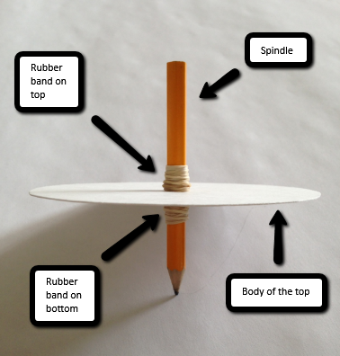

Figure 1. A simple way to construct a spinning top.
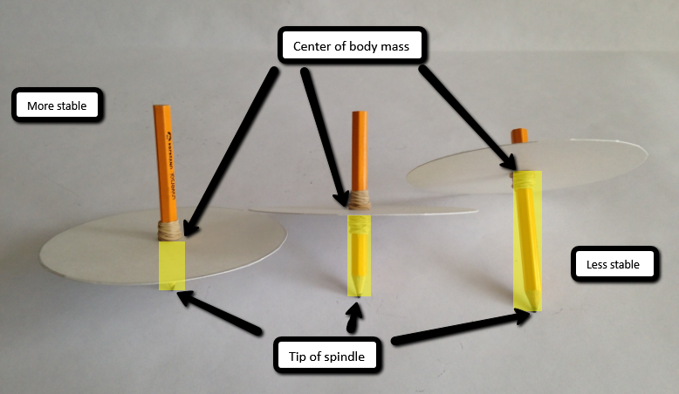

Figure 2. The effect of the height of the body along the spindle on top stability.

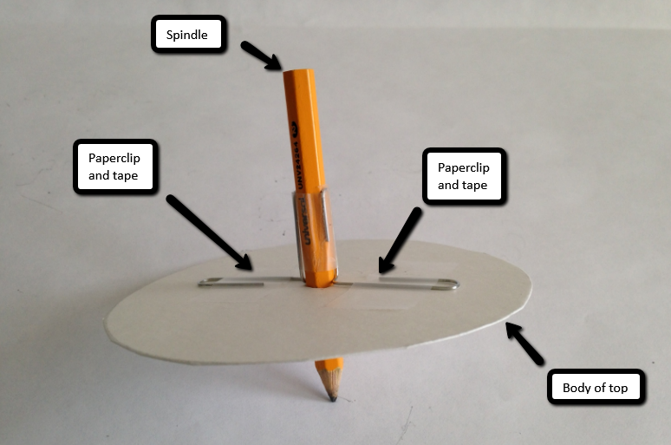

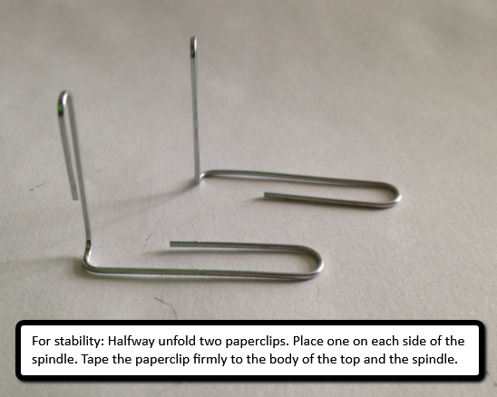
Figure 3. One way to stabilize a top by keeping the height of the body symmetrical.

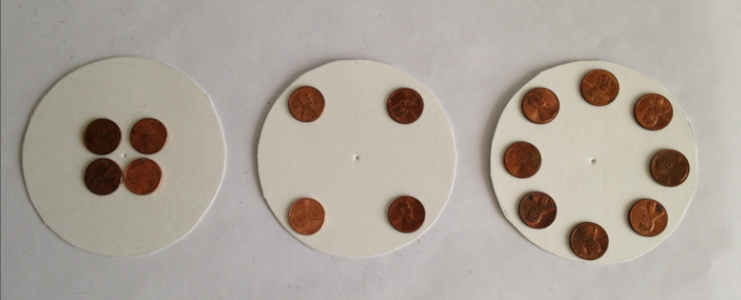
Figure 4. A schematic of how a student could test the effect of mass distribution on spin duration. The top on the left will have the shortest spin duration, while the top on the right will have the longest.

Module Description

Materials: Quantities are based on 36 participants
- printed handouts (36)  - scissors (24)  - drawing compasses (21)  - pennies (1,100, $11)  - ¾” masking tape (16 rolls)  - stopwatches (12)  - 1” rubber bands (2 pkgs, 150 each)  - pencils, small scoring (50)  - pencils, standard (30)  - ¼” dowels in various lengths, from 6” to 12” (65)  - bamboo skewers 10” to 12” long (24)  - 5” posterboard squares (60)  - 9” x 12” posterboard rectangles (90)  - modeling clay (1 ¼ lb) | - pencil sharpeners (3)  - metal paper clips, No. 1 (2 boxes)  - 12” rulers (18)  - 1” and 2” metal washers (30 each)  - 5” paper plates, heavy (30)  - 9” or 10” paper plates, heavy (45)  - cardboard pieces, aprox. 20” on a side (6)  - coffee stirrers (1 package)  - 5” plastic plates (20)  - 9” or 10” plastic plates (20)  - homemade tops (3)  - markers (3)  - post-it posters (2)

Preparation:
- Print handouts in advance (1 per student)
- Plan how students will split into pairs
- A room with large tables should be reserved where students can spread out and use supplies freely
- Plan how many facilitators will help with the activity and how they will distribute themselves among students (it is helpful if each facilitator chooses a set group of students so there is continuity of student support throughout the investigation)
- Set out the materials before the investigation
- Review the timing of the activity

Timeline:
- Introduction 5 min.
- Brainstorm 5 min.
- Testable questions 5 min.
- Planning the investigation 10 min.
- Investigation 35 min.
- Clean up 5 min.
- Interpreting data 10 min.
- Sharing conclusions 10 min.
- Reflecting on the process 5 min.
- Poster (optional)
- Engineering challenge (optional)

Starting Point for Inquiry:

The goal of this activity is to conduct a mini-investigation, during which the students will practice the skills in pairs that they will need to carry out a scientific project. While projects often take months or years, this mini-investigation will lightly touch on the same processes important to a scientific project over the course of 90 minutes. This investigation will also prepare students to be comfortable focusing their learning on the process and design of their investigation, rather than being overly concerned that the results are what they expect. Students should learn that it is OK if they don’t find the answers that they expect, as long as they address the questions in a scientific manner.

Explain these goals of the activity, and then give an overview of the process that students will experience. Students will investigate spinning tops. Their objective is to test some factors that they think might influence how long a top can spin. Tell students that they will first brainstorm factors that might affect spin duration. They will then form a testable question and use the materials to determine whether spin duration changes in response to their variable. After students investigate their question in pairs, they will interpret their results and share their conclusions with the rest of the class. After reading the detailed procedure, use the “facilitation cheat sheet” (Supplemental documents) during instruction as a reminder of key points.

Detailed Procedure:

- Introduction 5 min.

Introduce inquiry and spinning tops.
- Today we will conduct a mini-investigation about spinning tops. We will go through many authentic scientific processes, but we will complete our project in the course of an hour and a half. To complete your project on time, you will receive prompts and time reminders along the way so you know where you should be in your investigation.
- Today, we have certain materials so we are going to provide a topic for your investigation.
Show the students an example of a simple spinning top.
- You will learn about how spinning tops work by using the materials that we have available. Today, we would like you to work with a partner to ask a testable question and make a prediction about what variables affect how long a top will spin. You will have time to write down your question and to decide what materials you will use. You will then have 35 minutes to use the materials and to collect data on how long your top spins to answer your question. You will interpret your data to see if you supported your prediction or if your prediction was not supported. You will then share your conclusions with the class.

- Don’t worry. You do not need to have any previous experience with tops to get through this mini-investigation. Not knowing about tops can be even more exciting, because you get to learn more as you go. Start asking questions with an open mind and think about things that you know. Have you ever seen a figure skater spinning? What might make a figure skater go faster or slower when they spin?
- You will also use this time to practice using a lab notebook. All of your ideas, questions, data, results, mistakes, and everything else should be written down in this notebook. Be sure to record your name and the date. Nothing is too small for your lab notebook. Write down any thoughts that you have. Describe the materials you are using. Do not allow yourself to do anything without writing it down in your notebook.

- Brainstorm 5 min.

Spin the sample top for the students.
- Brainstorm factors that could affect how long the top spins.
Write them on the board. See facilitation tips on the “cheat sheet” (supplemental documents).

- Testable questions 5 min.

Show the students the materials that are available.
- A testable question is a question that you can answer by taking measurements. You will have five minutes to write down a testable question and to make a prediction about the outcome of your investigation. When you begin asking questions, think of what you can measure to answer the question. Does your question address the goal of the investigation (as in, does your question address a variable that might affect the spin duration of a spinning top)? What kind of top will you start with? What will you change about the top? Are you changing one variable or multiple variables? Be sure that your question allows you to address one variable at a time! What will you measure and when will you measure it? Finding answers to these questions is evidence that you have a testable question. What do you predict the answer to your question will be? How will you know when you have answered your question?
- Write EVERYTHING down in your lab notebook! All ideas and discarded questions should go in there too.
Check in with students to see if they are coming up with testable questions. Is their design simple? Can they do it with the materials provided? Are they planning to change one variable at a time? Are they planning to measure spin duration? If they are really stuck, show them Figure 3 (tops with pennies in different arrangements) and ask them what they think will happen to spin duration with the different configurations. Can they test their prediction?

- Planning the investigation 10 min.

Students should draw the tops that they plan to make and write down a materials list on the “student handout” (supplemental documents). Students should also construct a data table and label it in the space provided. At a minimum, the data table should include the variable they are changing, the trial number, and the spin time (students may also want to include who was spinning the top or other observations). They can get their materials when they have planned their investigation. After constructing their tops, they can pick up a stopwatch from a facilitator. Make sure they plan to change only one variable at a time.

- Investigation 35 min.

- By the end of 35 minutes, you must have all the data you need to try to answer your question. You should work together to construct your tops. Be sure to record any data you collect and what you change about your tops. Ask yourself if what you change about your top will help to answer your question. How can you make your experimental design simpler?
Give students time checks every five or ten minutes. Make sure that students are recording appropriate data and changing one variable at a time. Remind students that they should replicate each measurement. Ask students to look at their data in the last few minutes and to decide if they can answer their question or not. If they can’t, what additional information would they need?
During the investigation, you can introduce students to the terms independent, dependent, and control variables.

- Clean up 5 min.

- All materials that have been cut or modified are recycled. All other materials are returned to the supplies box.

- Interpreting data 10 min.

Students discuss what conclusions they can draw with their partners.
- Write down your conclusions, because you will share them with the rest of the class.

- Sharing conclusions 10 min.

Allow each student group to share their main conclusions with the class. These can be based on their data, but may also include other observations they made during the investigation (e.g. spin duration was different for different spinners).

- Reflecting on the process 5 min.

Ask students to share which steps of the scientific method they used during this investigation. Ask students what they learned about being a scientist (what did they learn about the process?). Ask them if they got excited about collecting data or when they found something that worked. Ask a couple of students to share these experiences. Then ask if any students got frustrated and when that occurred. Tell students that being frustrated and confused is part of the scientific process, but what it means is that they are challenging themselves and learning more than they could from reading about a topic.

- Poster (optional) additional 15 min.

A poster is a common method used by scientists to communicate their results to the scientific community. Place a post-it poster on the wall that is divided into sections for Intro, Methods, Results, and Conclusion. Ask a student group to volunteer their investigation for the poster. Make a simple poster using their notes from the lab notebook as a class. Give the poster a title. Write their question, bulleted methods, results, and conclusion in one to three sentences each. Draw an example of their top. Alternatively, hand out the sample poster (supplemental documents) and discuss each component. Explain that posters for scientific conferences are more detailed than this, but have the same components.

- Engineering challenge (optional) additional 15 min.

If there is extra time, ask students to use what they’ve learned from their investigation and the class to make a top that will spin for at least ten seconds. Tell them to discuss with their partners why they are making certain design decisions. This challenge can also be performed during another class period as an assessment of what students learned during their investigation.

Learning Goals:
- Practice the arc of a scientific project
- Ask testable questions
- Collect data
- Interpret data

Possible pitfalls:

Students that feel uncomfortable with science or physics may want to allow their partner to construct the top or ask the questions. Help to avoid this pitfall by telling students early that no knowledge of physics is required for the activity.

Students of any age often have trouble changing one variable at a time. Explain to students why they can’t be sure if they are addressing their question when they change more than one variable at a time. Check in with students and ask them how their trials differ. They may not even recognize that they have changed multiple variables. Ask them what other variables they could keep constant.

Students may be overwhelmed by the multitude of materials which can slow down the investigation. You can decrease the number of choices to help with this potential issue. For more advanced students, you can consider giving them more freedom in their question. Tell them to “learn what they can about how tops work” instead of “learn what makes tops spin longer.”

Students who test the effect of weight on spin duration but do not make their tops sufficiently symmetric (either by cutting the base unevenly or distributing pennies/washers unevenly) often come away with the misconception that lighter tops spin longer. Prepare symmetrically weighted tops of different weights (e.g. Figure 4) to demonstrate the expected outcome. Ask students why spinning your tops supports the opposite conclusion. Students should see that your tops are more symmetrical than theirs, and conclude that more weight does increase spin duration if the tops are symmetric.

Students sometimes make their factor or interpretation too complex. For example, students may want to test how the shape of the base affects spin duration. They may want to make a star, heart, circle, and square. In this case, ask them why they expect the shapes to spin for different amounts of time. In many cases, this question boils down to the symmetry of the top. Ask students if they can think of a simpler comparison to address top symmetry. For example, students could place the pencil in the center of the circle or off center.

It may be difficult for students to finish their investigation in the allotted time. You can either give them more time with the materials or construct some simple tops for them to modify before they start the investigation. Ideally, the students engage with the materials as much as possible so that they have ownership over the investigation.

Glossary:

Testable question - a question with clear dependent and independent variables that can be tested given the allotted time and materials
Hypothesis - a proposed explanation made on the basis of limited evidence as a starting point for further investigation
Independent variable - The variable that is purposefully manipulated by the experimenter so the outcome can be measured; although not manipulated by the experimenter directly, time can also serve as an independent variable
Dependent variable - the variable(s) that is (are) measured and is (are) predicted to be affected by changes in the independent variable
Control variable - variables in an experiment that are kept constant across trials (not to be confused with an experimental control or control group)

Useful References:

Exploratorium Institute for Inquiry (2006). Workshop I: Comparing approaches to hands-on science in Fundamentals of Inquiry Facilitator’s Guide. Exploratorium, San Francisco.

Figure Skating Video: https://www.youtube.com/watch?v=b5kj8dvDeN4
Figure Skating Video: https://www.youtube.com/watch?v=fDj3Vf4hJGg
Tops video: https://www.youtube.com/watch?v=8I-dZhxiEP8
Tops Video: https://www.youtube.com/watch?v=qquek0c5bt4 (stop after 2:20min)

NGSS Resources:
http://www.nextgenscience.org/california

Practice 3 Planning and Carrying Out Investigations

Students should have opportunities to plan and carry out several different kinds of investigations during their K-12 years. At all levels, they should engage in investigations that range from those structured by the teacher—in order to expose an issue or question that they would be unlikely to explore on their own (e.g., measuring specific properties of materials)—to those that emerge from students’ own questions. (NRC Framework, 2012, p. 61)

Whether students are doing science or engineering, it is always important for them to state the goal of an investigation, predict outcomes, and plan a course of action that will provide the best evidence to support their conclusions. Students should design investigations that generate data to provide evidence to support claims they make about phenomena.

Over time, students are expected to become more systematic and careful in their methods. In laboratory experiments, students are expected to decide which variables should be treated as results or outputs, which should be treated as inputs and intentionally varied from trial to trial, and which should be controlled, or kept the same across trials. Planning and carrying out investigations may include elements of all of the other practices. (NGSS Appendix F Science & Engineering Practices, p. 7)

